It has POS.
Install CBORD gold development for odyssey, and then modify the scripts (CSgold handler express file, and the files that this file is pointing to) according to the API sent. Connect to odyssey to environment, do not use syracuse credentials, only cbord.

Leer documentacion enviada.

CBORD is already install
CBORD gold tender

Stage a workstation

Amount due -> run gold tender, si da error,

Looking at CBORD Odyssey, see what is missing on the document
Cuenta de syracuse -> list records -> recordtypes -> suite adapter log -> view records

Tengo que correr cbord gold, me va a dar una url
Y esta va a ser el json, pero este no es de cbord gold, tengo q correr cbord gold para q aparezca:
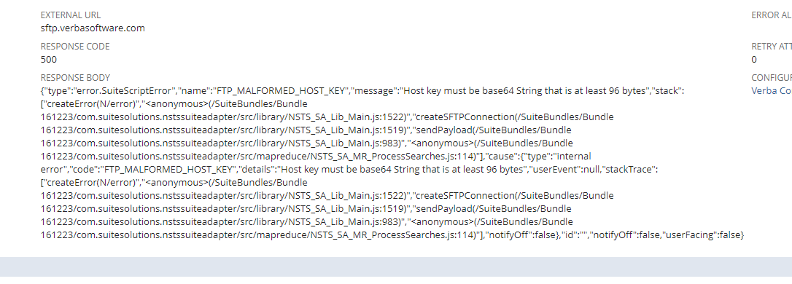
Change configuration ->
Primero hacer el stage de la register
https://4510125-sb1.app.netsuite.com/app/common/custom/custrecordentry.nl?rectype=84&id=401

